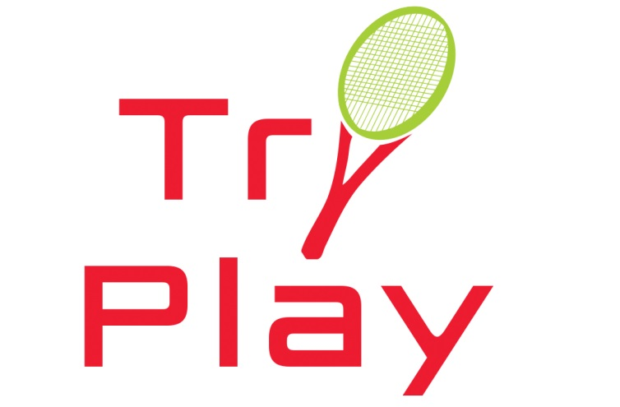

Try Play Curriculum
“Try Play” is a fun and engaging program offered as a follow-up to Try Tennis that allows players to learn the ins-and-outs of match play. This program is a "play-to-learn" session for adult beginner players that want to build confidence in their newly learned skills and is the perfect next step in getting comfortable with match play. Your job as the instructor is to keep participants engaged and motivated throughout the process of teaching players how to play a tennis match.
This program is most ideal for Try Tennis graduates as well as beginner tennis players rated 2.5 or below and are not registered in the USTA.
Please use the curriculum guide below as an outline for your Try Play Program. REMINDER: Some players may develop more quickly than others. Use your discretion when it comes to how much time is needed for drills versus match play. Each Try Play session should be at least 6 hours in length.

Breakdown of Class 1
Instruction (25-30 mins)
- Warm up (ball skills)
- Instruction focused on reviewing forehands and backhands
- Explanation of how to keep score (points (15, 30, 40, deuce), games) and who calls the scores before each point
Game Play (30 min-35 min)
- Have players play a game with a doubles partner, switching partners after each game, or making sure each player has served at least one game.
- Teach players simple tennis etiquette rules (What to do with a ball after a fault, when to call the balls out and who calls the ball out, do not talk/make noise when the ball is on the other side of the court, etc…)

Breakdown of Class 2
Instruction (25-30 mins)
- Warm up (ball skills)
- Instruction focused on approach shots, volleys and overheads
- Explanation of positioning of players on the court for singles/doubles
- Explain movement on court with doubles partner and communication of when to switch sides during a rally and covering lobs
Game Play (30 min-35 min)
- Have players play a set with a doubles partner, switching sides after first game, then every two.
Breakdown of Class 3 and 4
Instruction (25-30 mins)
- Warm up (ball skills)
- Have players serve and return and switch sides
- Explanation of tiebreak
- Go over tiebreak scoring (7 point and 10 point), positioning, when to switch servers, sides, etc..
Game Play (30 min-35 min)
- Have players play tiebreakers using the 7-point and 10-point tiebreak in Class 3
- Have players use the Coman tiebreak in Class 4 (Switch sides after first point, then after every four points)
- Play singles and doubles if court space allows
Breakdown of Class 5 and 6
Instruction (5-10 mins)
- Teach them to spin racquet, who decides who serves first/side of the court to be on.
- Explain what occurs in a warm-up before a tennis match: rally from baseline with person across from the net, volleys and overheads and switch, and take serves.
Game Play (50 min-55 min)
- Have players warm up like they would in a regular match: rally from baseline, volleys and overheads and switch, and take serves. Try to keep warm up to 5-7 minutes
- Feel free to switch up partners after each set
- Have players racquet tap after match is completed

